ITS California and California Transportation Foundation 2023 Scholarships
For Studies in Intelligent Transportation Systems (ITS)
______________________________________________
AWARD: Two scholarships to advance academic studies and careers in the field of ITS. Eligible students must be Masters/Ph.D. students in an accredited university in California, studying any ITS-related field including, for example, engineering, computer science, transportation planning, or public policy.
VALUE: $5,000 each for the 2023 - 2024 academic year.
Application Requirements:
Selection will be based on academic ability, stated career objectives and interests, and supporting letters of reference. International students on F-1 and J-1 visas will be considered. To be eligible, candidates must provide:
- Official and most recent transcript showing courses relevant to ITS.
- List of courses in which the candidate is currently enrolled.
- Proposed or current list of course enrollments for the 2023 - 2024 academic year.
- Evidence of registration and/or acceptance for study in an undergraduate or graduate program at an ABET- or WASC-accredited California university.
- Two (2) letters of reference that include assessment of the candidate’s academic ability and record, commitment to a career in the ITS and any other personal attributes that indicate the candidate is worthy of the award. The letters should describe the candidate's scholastic performance and research, work, or other activities related to ITS.
- An essay not to exceed 750 words, covering motivation for working in ITS field(s) and describing how the candidate grew interested in the topic(s).
- A video clip not to exceed 2 minutes comprised of an “elevator pitch” of the candidate and his/her perspective on ITS.
- A 1-page resume.
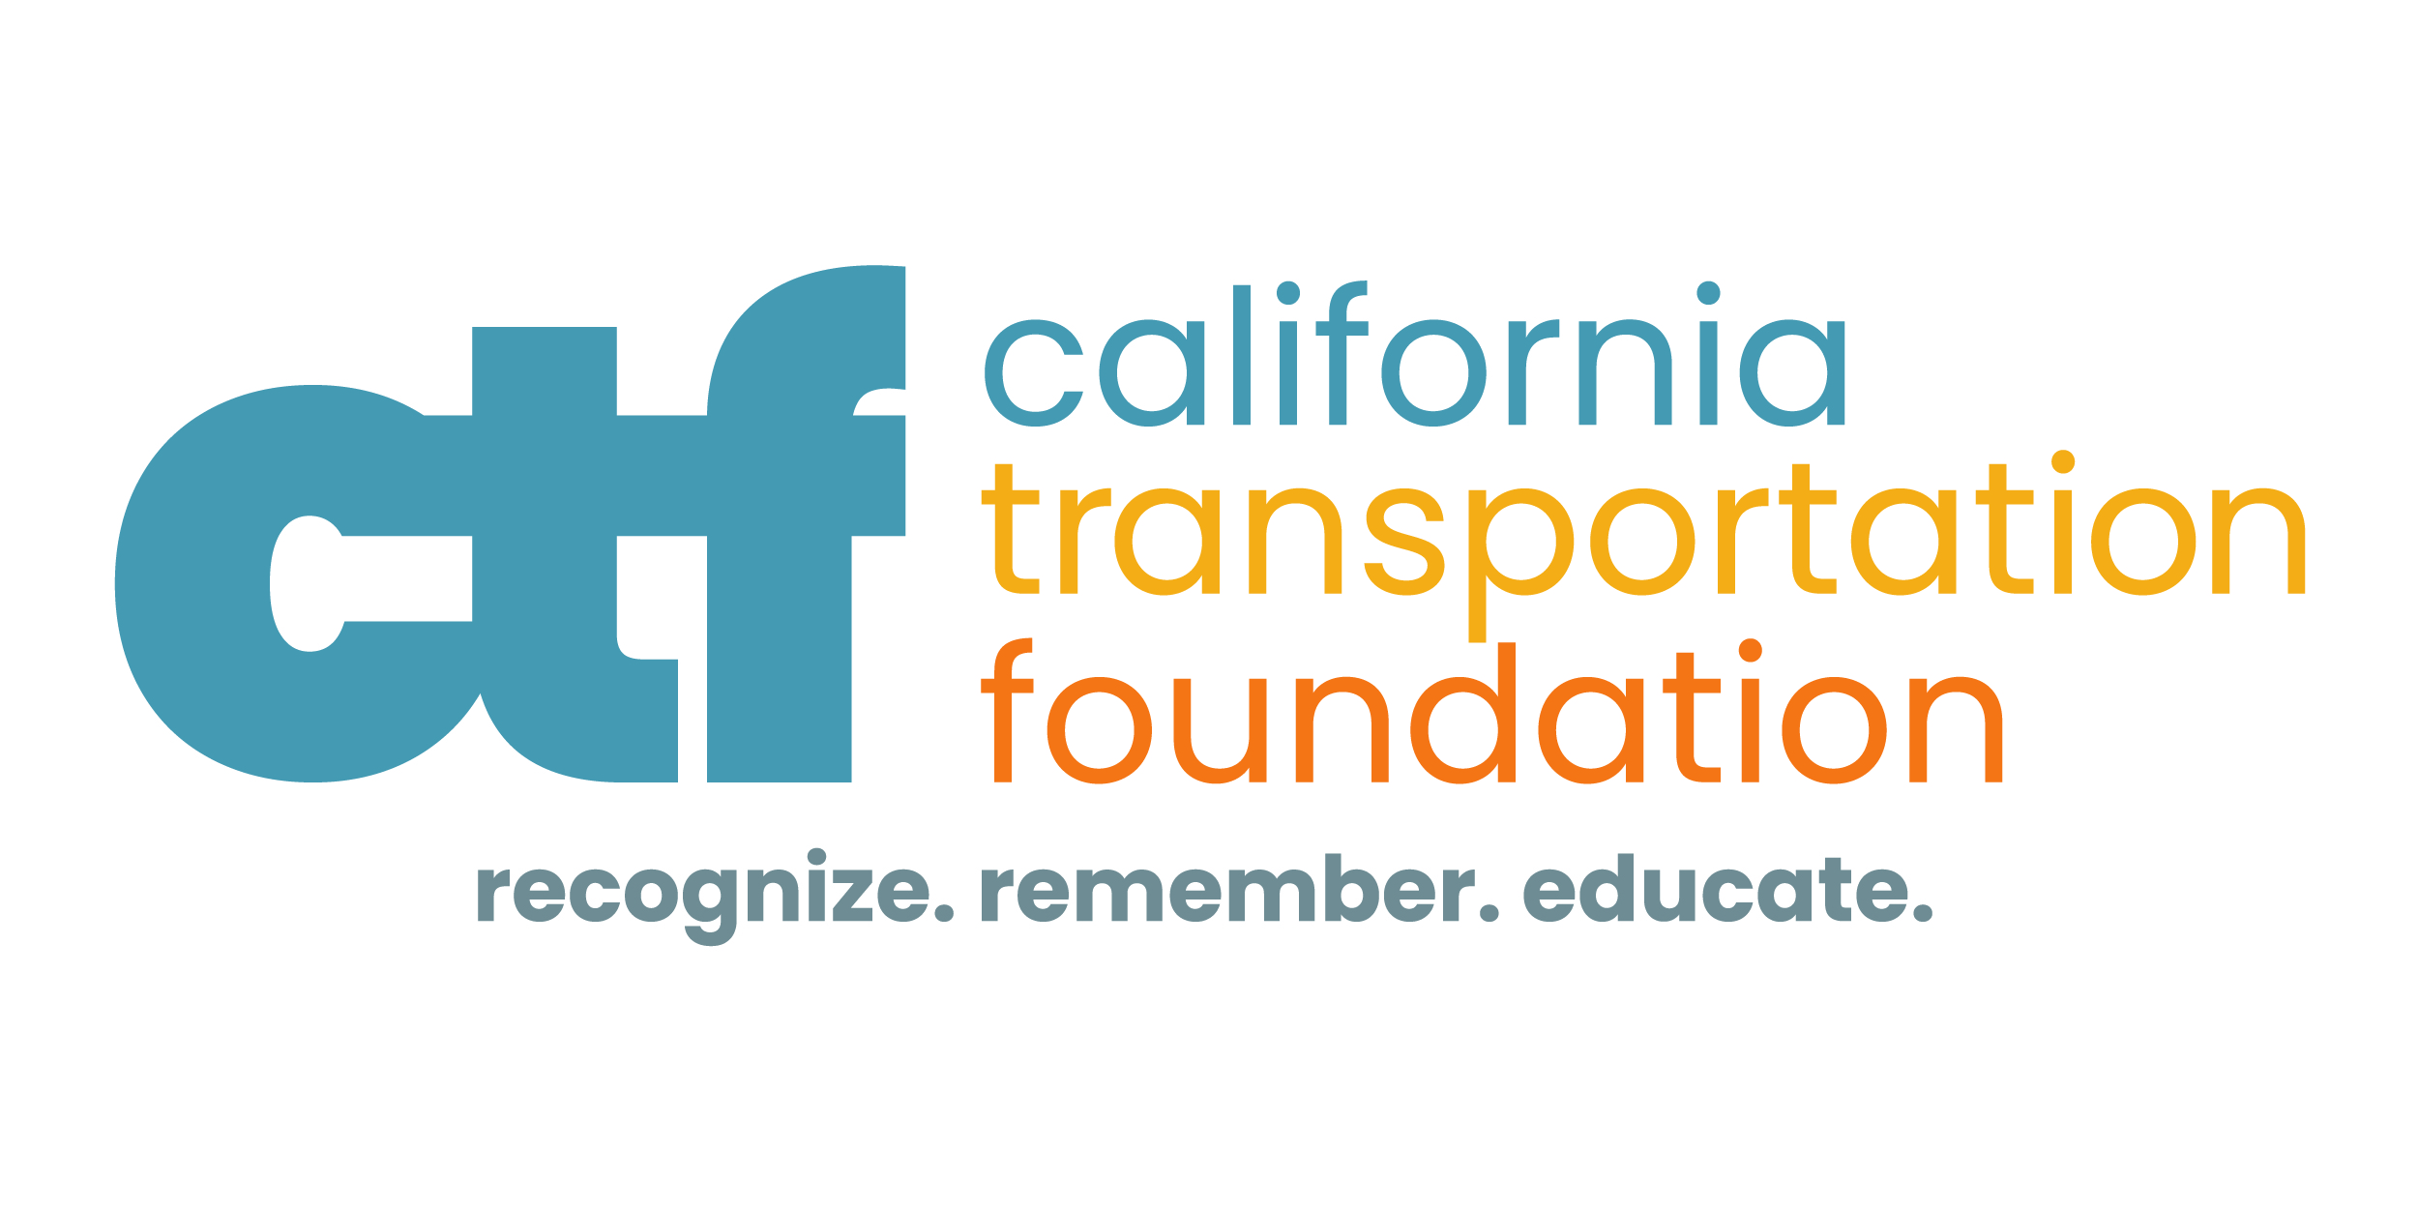
Application Deadline Extended to June 9, 2023
Applications must meet all the requirements to be considered.
Incomplete applications will not be reviewed.
Apply here: https://apply.mykaleidoscope.com/scholarships/ITSCAScholarship
Visit us at: www.itscalifornia.org and www.the-ctf.org/scholarships

