ITS California and California Transportation Foundation 2024 Scholarships
For Studies in Intelligent Transportation Systems (ITS)
______________________________________________
AWARD: Two scholarships to advance academic studies and careers involving transportation technologies. Eligible students must be Masters/Ph.D. students in an accredited university in California, studying any transportation technology field including, for example, engineering, computer science, transportation planning, or public policy. This is open to all students who meet these eligibility criteria, regardless of race, ethnicity, gender or socioeconomic status.
VALUE: $5,000 each for the 2024 - 2025 academic year.
Application Requirements:
Selection will be based on academic ability, stated career objectives and interests, and supporting letters of reference. International students on F-1 and J-1 visas will be considered. To be eligible, candidates must provide:
- Most recent transcript showing courses relevant to ITS.
- List of courses with which the candidate is current enrolled.
- Proposed or current list of courses enrolled for the 2023 - 2024 academic year.
- Evidence of registration and/or acceptance for study in an undergraduate or graduate program at an ABET- or WASC-accredited California university.
- Two (2) letters of reference that include assessment of the candidate’s academic ability and record, commitment to a career in the ITS and any other personal attributes which indicate that the candidate is worth of the award. The letters should also describe scholastic performance and research, work or other activities related to ITS.
- An essay not to exceed 750 words, covering motivation for working in ITS field(s) and describing how candidate grew interested in the topic(s). Leadership and community involvement and commitment to inclusiveness should be included in the essay, as these are considerations in the selection.
- A video clip not to exceed 2 minutes comprised of “elevator pitch” of the candidate and his/her perspective on ITS.
- A 1-page resume.

Application Deadline: May 10, 2024
Applications must meet all the requirements to be considered. Incomplete applications will not be reviewed.
Email application to: ITS Scholarship Chair – its-caadmin@itscalifornia.org
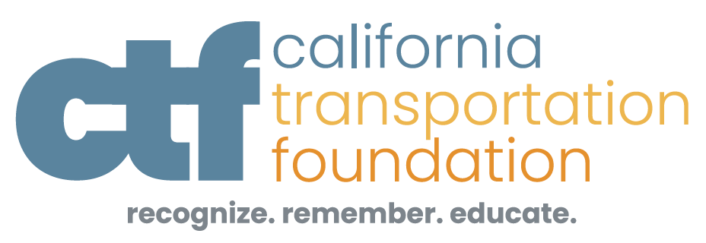
Visit us at: www.itscalifornia.org and www.the-ctf.org/scholarships

